(Assignment on Join Operation)

- Display employee name, address, department no and department name.
A: SELECT e.ename,e.address,e.dno,d.dname
FROM employee e JOIN department d
ON e.dno=d.dnumber;
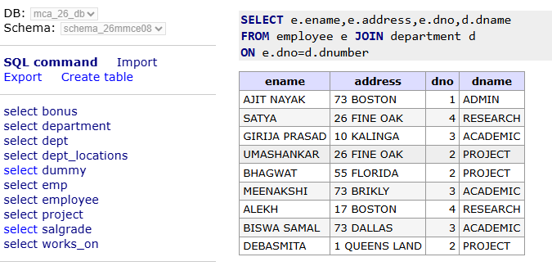
- Display managers name, department name, date of joining of manager, and salary of managers.
A:
- Display project name, project number and project location and total hours of all active projects.
A: select p.pname,p.pnumber , p.plocation, sum(w.hours) as total_hours from project p join works_on w on p.pnumber=w.pno group by pnumber;
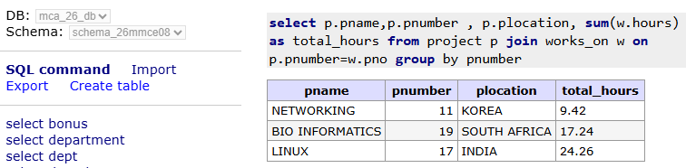
- Display all the employees who are working in ACADEMIC.
- Display the managers’ details who started on ’17-JUL-99’.
- Display the details of LINUX project employees.
- Display the details of the people who projects are located at SOUTH AFRICA.
- Display the employees who are staying in INDIA.
- Display all the employees total number of hours spent in their respective project.
- Display the total hours spent on LINUX 15. Display all INDIA project members.
- Display all the employee names who are belonging to the RESEARCH department.
- Find the total working hours of each manager.
- Display the employee names those who are in project number 19.
- Display project name, project location, employee serial no and total working hours of the employees.
- Display details of employees who are not managers.
- Employees who work on projects in departments different from their own
- Employees who work on projects located in the same location as their department

